AM000-Asia-China Mirror-E. Han-Four Dragons-Changsha-Chengdu Prov.

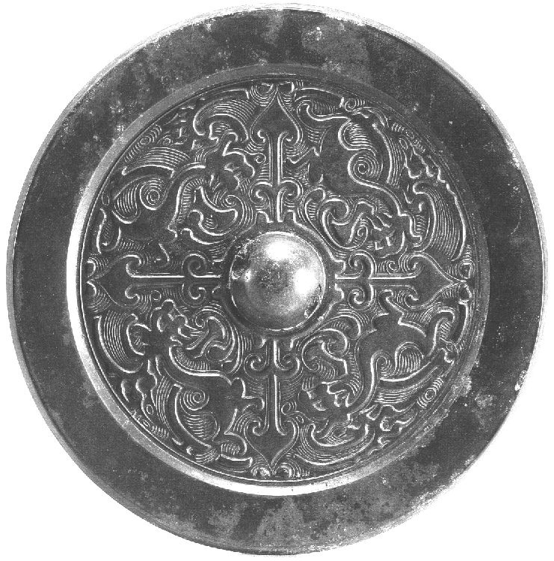

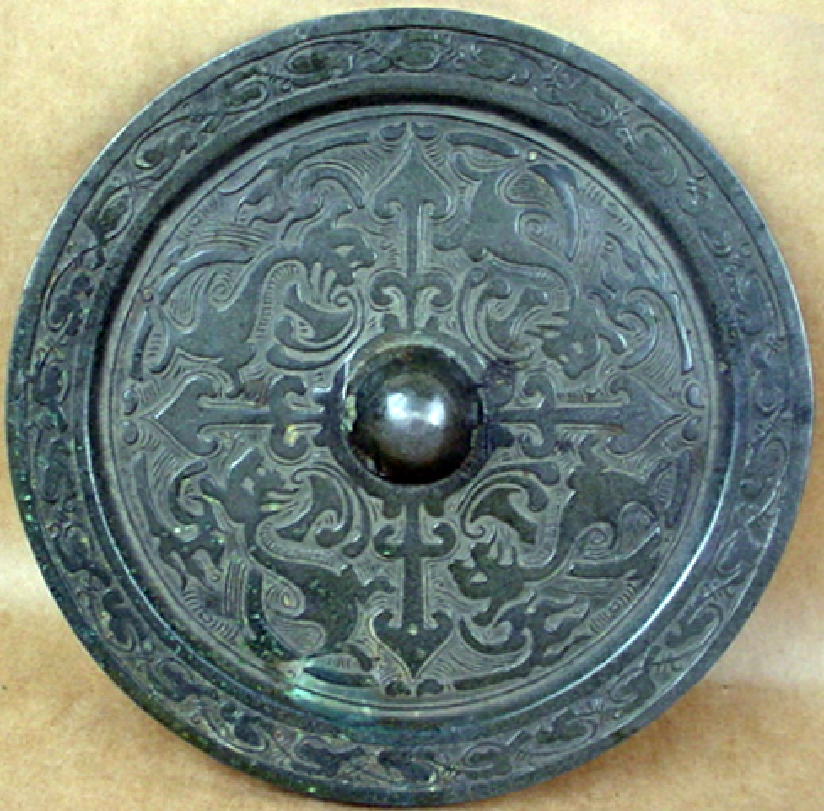

四龍紋 Four dragons mirror Eastern Han Dynasty, copy excavated by the Hunan Provincial Museum in 1952, in Changsha, Chengdu Provinces. The radial four-leaves divide the mirror into four zones, each with an interior dragon arc pattern, which may signify vanquished foes. There is a wide flat edge of the mirror rim with a cloud pattern that may signify the perimeter of the Chinese state.

The Eastern Han: 東漢 (Dōng Hàn) or Later Han 後漢; (Hòu Hàn) dynasty began on 5 August 25 CE, when Liu Xiu became Emperor Guangwu of Han. It ushered in a period of four foreign rebellions. These foreign powers may be indicated by the four dragons. The first war was with the Korean Koguryeo (Goguryeo) state that rebelled in 25 CE and was conquered in 30 CE by Wang Mang (Yü 1986: 450). The second war was with the Vietnamese Trưng Sisters (ca. 12 - 43 CE) in 40 CE, who were crushed by the Han general Ma Yuan (d. 49 CE) in a campaign from 42–43 CE (de Crespigny 2007: 562, 660; Yü 1986: 454). The third war was with the Xiongnu (Huns) who were estranged from the Han until their leader Bi (比), a rival claimant to the throne against his cousin Punu (蒲奴), submitted to the Han as a tributary vassal in 50 CE. This created two rival Xiongnu states -- the Southern Xiongnu led by Bi, an ally of Han, and the Northern Xiongnu led by Punu, an enemy of Han (Bielenstein 1986: 237–238; Yü 1986: 399–400). The Northern Xiongnu conquered the Tarim Basin in 63 CE, established a base at Turfan and invaded the Hexi Corridor in Gansu (Yü 1986: 413–414). Dou Gu (d. 88 CE) defeated the Northern Xiongnu at the Battle of Yiwulu (Hami) in 73 CE, and expelled the Northern Xiongnu from Turfan pursuing them along the northern Silk Road through Hami to Lake Barkol, thence to the Altai Mountains and the Ili River valley in 91 CE, where their military disintegrated after the decease of their leader, Tanshihuai (Yü 1986:, 444–446). The fourth war was with the Kushans when the Kushan ruler Vima Kadphises (r. c. 90–c. 100 CE) proposed a marriage alliance with the Han which was rejected in 90 CE. The Kushan war was won due to the Kushan's lack of forward supplies by Ban Chao (32–102 CE) the general and cavalry commander in charge of the administration of the "Western Regions" (Xinjiang Autonomous Region) in 91 CE (Torday 1997: 393; de Crespigny 2007: 5–6). Having conquered these four dragon powers, one might suppose that this mirror was produced as a symbol of military victory over four vanquished foes shortly after the fourth foe was conquered in 91 CE.

References:

Bielenstein, Hans. 1986. "Wang Mang, the Restoration of the Han Dynasty, and Later Han," in *The Cambridge History of China: Volume I: the Ch'in and Han Empires, 221 B.C. – A.D. 220*, 223–290. Edited by Denis Twitchett and Michael Loewe. Cambridge: Cambridge University Press.

de Crespigny, Rafe. 2007. *A Biographical Dictionary of Later Han to the Three Kingdoms (23–220 AD)*. Leiden: Koninklijke Brill.

[Luoyang chu tu tong jing - Luoyang bo wu guan bian.](javascript:open_window() 1988. [洛陽出土銅鏡 / 洛阳博物馆编.](javascript:open_window(). Beijing : Wen wu chu ban she : Xin hua shu dian Beijing fa xing suo fa xing.

Torday, Laszlo. 1997. *Mounted Archers: The Beginnings of Central Asian History*. Durham: The Durham Academic Press.

Yü, Ying-shih. 1986. "Han Foreign Relations," in *The Cambridge History of China: Volume I: the Ch'in and Han Empires, 221 B.C. – A.D. 220*, 377–462. Edited by Denis Twitchett and Michael Loewe. Cambridge: Cambridge University Press.

Zhōngguó qīngtóngqì quánjí biānjí wěiyuánhuì biān 中国青铜器全集编辑委员会编 .[Editorial Board of The Complete Works of Chinese bronzes] 2005. 中国青铜器全集.16，铜镜 [Complete Works of Chinese Bronze .v. 16, bronze mirrors] 文物出版社 [Beijing: Cultural Relics Publishing House] ISBN: 7-5010-1044-7

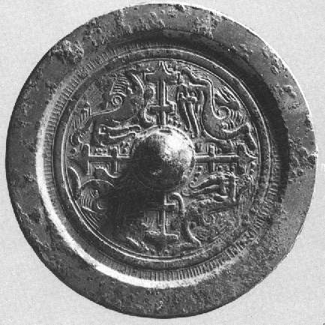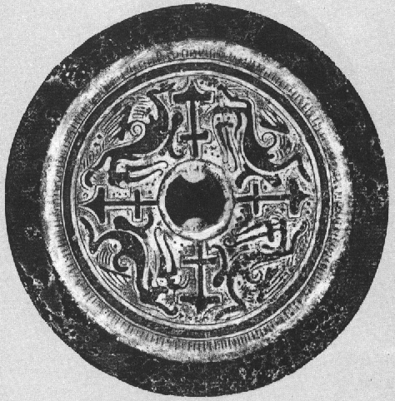53 Eastern Han 4 Dragon Bronze Mirror from [Luoyang chu tu tong jing](javascript:open_window()  1988: fig. 53东汉龙马纹镜 and p.8. Diameter 12.1 cm, weighing 270 g , excavated from Yuejia village tomb 627, Luoyang, Henan Province. Mirror with 4 zones, 4 carved dragon-head animal bodies and a central plain round boss.

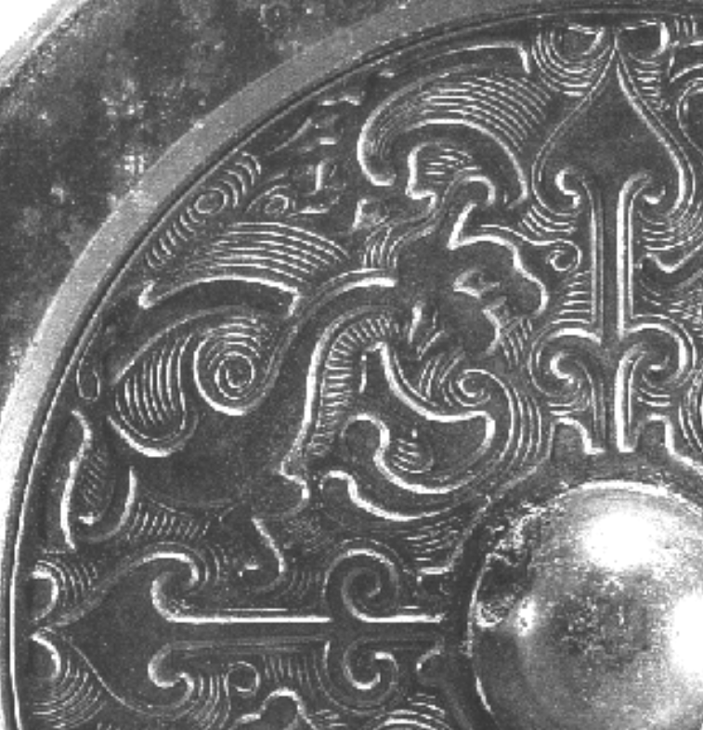 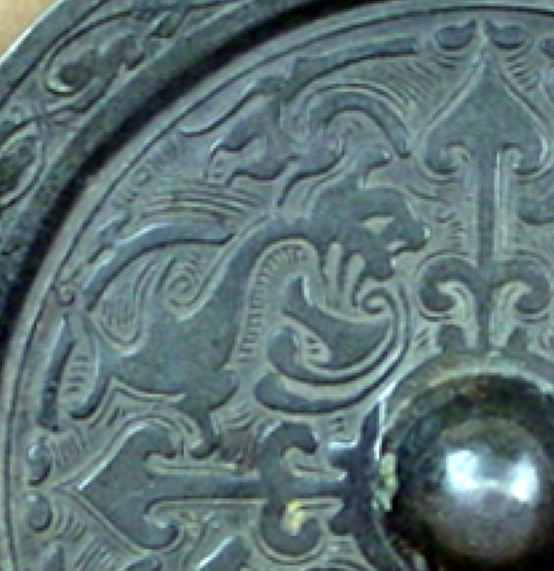 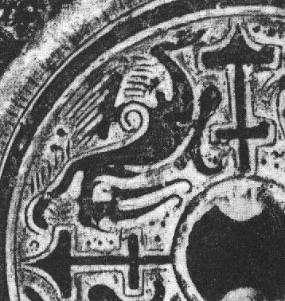

Details of three Eastern Han 4 Dragon mirrors.